Social Media Example #1



Looking for a way to connect with other readers from the comfort of your home? Join the [Book Club Name] Book Club! 📖 Five times a year, we select a new title to explore together. Don't miss out on the literary fun! #VirtualReadingCommunity #BookClub

Social Media Example #2



Escape reality with a good book and join the [Book Club Name] Book Club! 🌟 Discuss your favorite reads, discover new authors, and engage in thought-provoking discussions with fellow book enthusiasts. Sign up now! You can find the link in [insert link location]. #VirtualBookClub #BookishCommunity #WeLoveReading

Social Media Example #3



Unleash your inner bookworm and join our thriving virtual book club! With diverse reads and engaging discussions, there's never a dull moment in our literary haven. Expand your mind, connect with fellow [insert community], and discover the magic of storytelling like never before. Join the [Book Club Name] Book Club today! 📖🌟 #BookClubMagic

Social Media Example #4

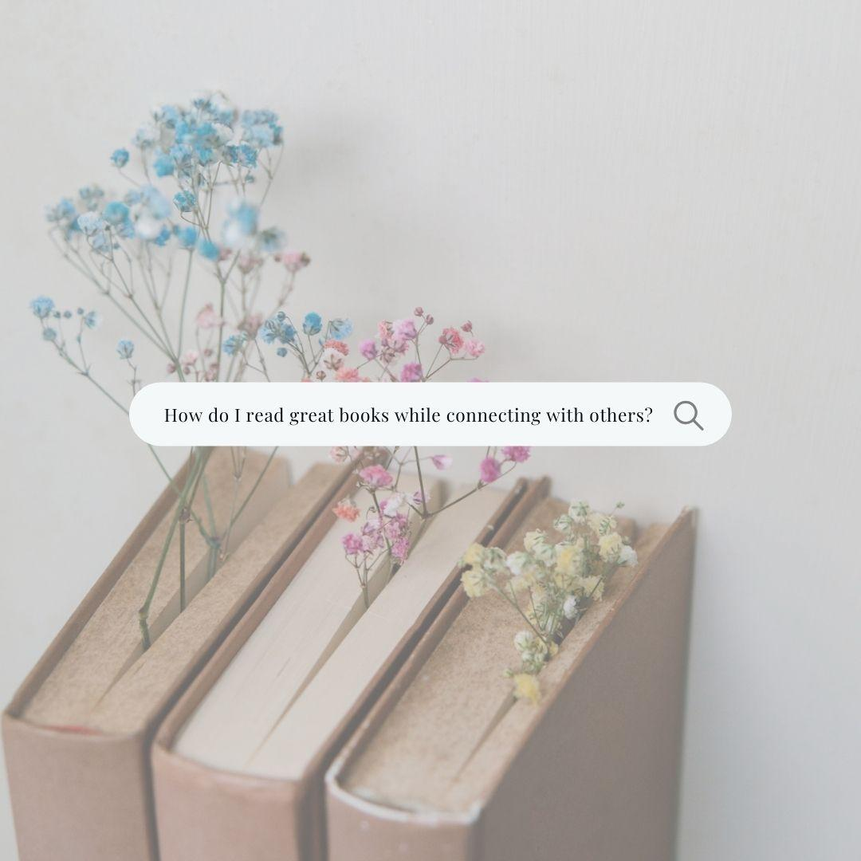

Seeking connection and inspiration? Look no further than the [Book Club Name] Book Club! Dive into captivating reads, exchange ideas with fellow members, and cultivate a deeper appreciation for fiction and nonfiction. Join our community of book lovers and embark on a journey of discovery together! 📚💡 #BookClubConnections

